[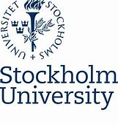](https://www.bing.com/images/search?view=detailV2&ccid=VLmyr1T9&id=C57A52F1A55D71F2B45473C4EF7E5B01FA579E96&thid=OIP.VLmyr1T9QqMz5xU_d0iJIgAAAA&mediaurl=https%3a%2f%2fsta.uwi.edu%2finternationaloffice%2fsites%2fdefault%2ffiles%2finternationaloffice%2fStockholm_University_logo.svg_.png&exph=322&expw=295&q=stockholm+university+logo&simid=608035138754053499&selectedIndex=24)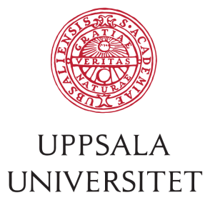

Application Form PhD Candidates

2019 PhD Seminar in Leiden, the Netherlands

“**Multilateral Cooperation in International Tax Law”**

|  |  |
| --- | --- |
| **Name (first and last):** |  |
| **Address:** |  |
| **E-mail:** |  |
| **University:** |  |
| **Title of your dissertation** |  |
| **What is the core issue of your dissertation (max 300 words)?** |  |
| **Supervisor(s):** |  |

**More Information**

Please email this form to [**belastingrecht@law.leidenuniv.nl**](mailto:belastingrecht@law.leidenuniv.nl) before 1st of July 2019.

The seminar is free of charge. Participating PhD students will get a certificate of participation.

**Signing**

**By signing you confirm your obligation to participate in the seminar.**

Date ……………………………………. Signature …………………………………………