Politics and Religion

in the Middle Ages and Today:

Thoughts of an American Medievalist

  - Keynote lecture by prof. Christopher M. Bellitto, Ph.D., Kean University, New Jersey USA
  - Fulbright Specialist, University of Groningen

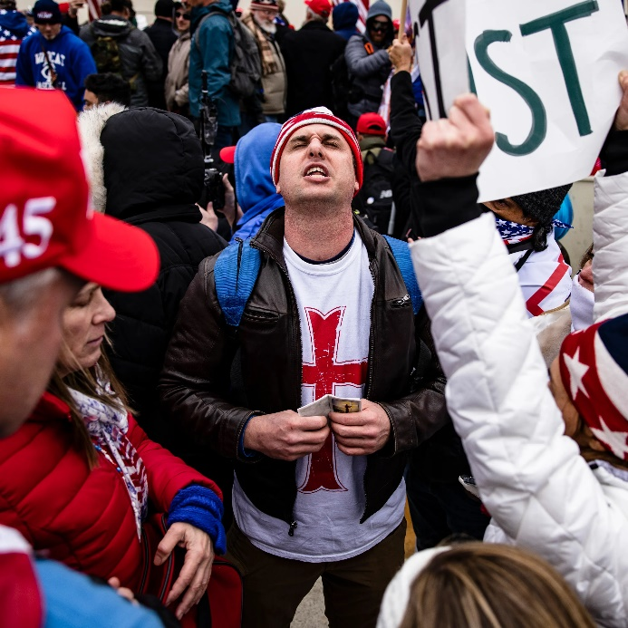

Place: Courtroom, Faculty of Theology and Religious Studies, Oude Boteringestraat 38, 9712 GK Groningen
Date: June 26th 2023, 19.00-20.30

Description
Studying the Middle Ages is no longer a quaint exercise in exploring an exotic past reflected in Lord of the Rings and Game of Thrones. What were the Middle Ages really – and why do they now matter in such an explosive way in terms of politics and religion? We’ll turn not only to the topics of the Crusades and race—then and now—but also to illuminating developments in the United States where a particular brand of Christian nationalism appeals to an idealized Middle Ages where church and state were fused in theocracy.

Image: The Capitol Riot and the Crusades: Why the Far Right Is Obsessed With Medieval History | Teen Vogue

